Design of porous crystals for energetically favorable
carbon dioxide capture and conversion

Professor Md. K. Nazeeruddin, Group for Molecular Engineering of Functional Materials (GFM)
Professor Wendy L. Queen, Laboratory for Functional Inorganic Materials (LFIM)

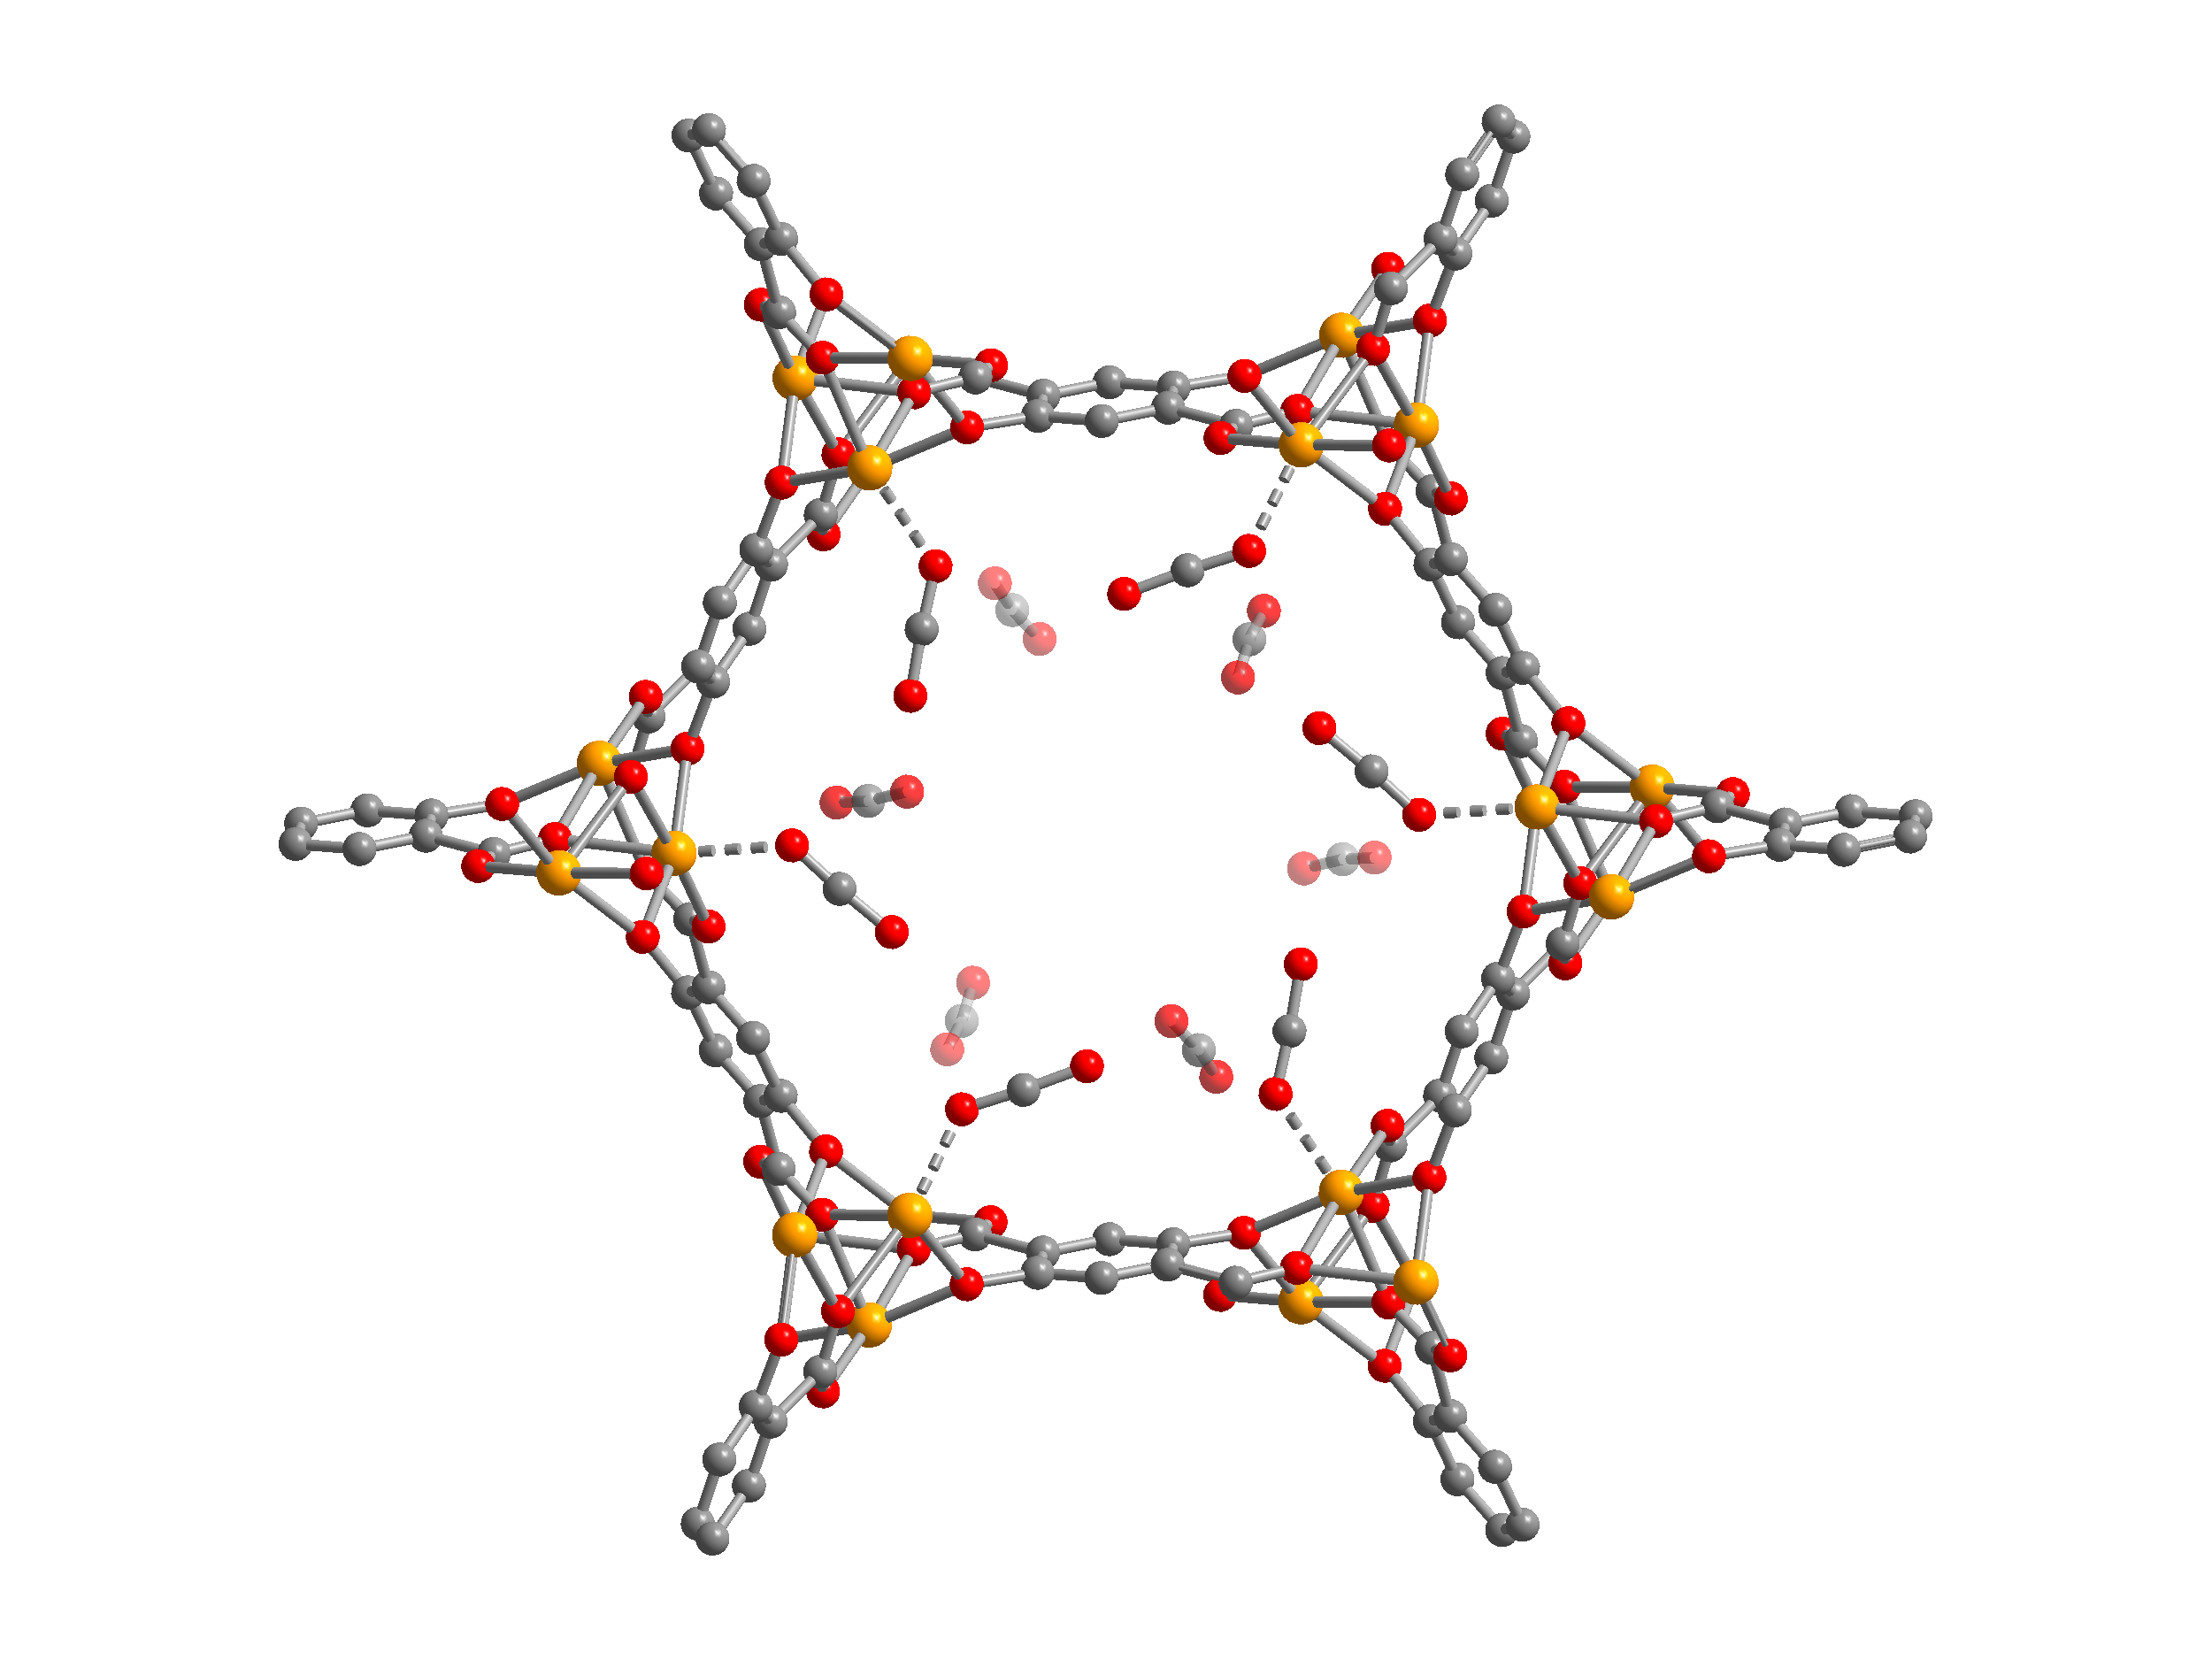
Metal-Organic Frameworks, best described as porous crystalline materials that consist of metal-ions or metal ion clusters that are interlinked by organic ligands, are a relatively new class of hybrid materials. Relative to their all-inorganic counterparts, these materials offer easy chemical tunability and unprecedented internal surface areas allowing them to selectively adsorb significant amounts of gas. These properties and their potential applicability in several energy related areas, such as gas storage and separation, catalysis, and sensing, have quickly brought MOFs to the forefront of science. The molecular nature of the organic linkers facilitates facile modification of the framework surface with a variety of functional groups. Furthermore, after liberation of solvent molecules from the framework channels via heat treatment under vacuum (a process called activation) many MOFs are known to exhibit open-metal coordination sites. It has recently been shown that high densities of these electron deficient, Lewis acid sites can enhance both binding energy and selectivity of various small molecules and also allow charge transfer on the framework surface for the conversion of small molecules into value added products. With the insertion of ligands that can post-synthetically bind various metals on the internal surface, it is hypothesized that MOFs could become paramount in areas coupled to carbon capture and conversion.
Figure 1. MOF framework with CO₂ adsorbed at the open metal site.
The objective of this project will be (i) to synthesize and characterize several ligands that are prone to form frameworks with high densities of open metal sites (in the GFM) and (ii) to carry out subsequent MOF synthesis, post-synthetic metalation, and characterization (in the LFIM). The ligands of interest will have bipyridine or catechol moieties offering us the means to post-synthetically decorate the frameworks with a variety of metals. For this project the students will carry out standard inorganic and organic synthesis coupled with a variety of characterization techniques such as x-ray diffraction, CO₂ adsorption and surface area measurements, NMR, IR, TGA, gas and/or liquid chromatography, and ICP-OES.

